# **Lesson Objectives**

1. Solve a linear equation graphically.
   1. by hand
   2. with graphing calculator
2. Determine if an ordered pair is a solution to a system of linear equations.
3. Solve a linear system of equations graphically.
4. Classify a system of equations:
   1. consistent-independent (one solution)
   2. consistent-dependent (infinite solutions)
   3. inconsistent (no solutions)

# Solve a Linear Equation Graphically

## Solve *f*(*x*) = *c* (*c* is some number)

* **EXAMPLE:** Use the graph of *y* = *f*(*x*) shown to the right to solve each equation. [2.2.55]

$f\left(x\right)=-1$

$f\left(x\right)=0$

$f\left(x\right)=2$

1. $f\left(x\right)=-1$ means that $____=-1$.  
   In the graph when $y=-1$, $x=____$

That’s the point: $(3,-1)$.

The solution to $f\left(x\right)=-1$ is $x=____$.

1. $f(x)=0$ means that $___=0$.

In the graph when $y=0$, $x=___$

That’s the point: $(4,0)$.

The solution to $f(x)=0$ is $x=____$.

1. $f(x)=2$ means that $___=2$.

In the graph when $y=2$, $x=___$

That’s the point: $(6,2)$.

The solution to $f(x)=0$ is $x=____$.

(a) 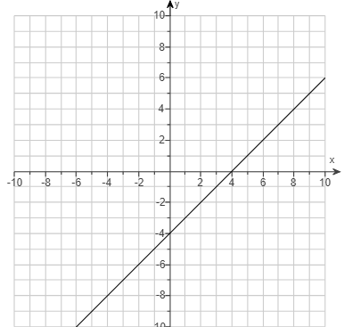

(b)

(c)

## Solve equation graphically

* **EXAMPLE:** Let *y*1 equal the left side and let *y*2 equal the right side of the given equation. Graph *y*1 and *y*2 and use the graph to solve the equation $x-3=-2$ [2.2-19]

$y_{1} = ____________$*y*-intercept: $(0,___)$, slope $m=___$ $\left(\frac{rise}{run}=\frac{___________}{________________}\right)$

$y_{2} = ______$*y*-intercept: $(0,___)$, slope $m=___$ (**______________** line through *y*-axis at – 2)

|  |  |  |  |
| --- | --- | --- | --- |
| **A.** | **B.** | **C.** | **D.** |
| $$x=1$$ | $$x=-1$$ | $$x=1$$ | $$x=1$$ |
|  |  |  |  |

You can also use the **GRAPHING CALCULATOR** to find the solution.

|  |  |  |  |
| --- | --- | --- | --- |
|  |  |  |  |
| 1. Press **Y=** button and put **LEFT** side of equation into $Y_{1}$ and put **RIGHT** side of equation into $Y_{2}$ | 2. Press **WINDOW** button and adjust settings to match the *x*-axis and *y*-axis in the answers | 3. Press **GRAPH** button to view the graph. | 4. Press the buttons **2ND TRACE 5**  which is in the **CALCULATE** menu - **intersect** |
|  |  |  |  |
|  |  |  |  |
| 5. First Curve?  Press **ENTER** | 6. Second Curve?  Press **ENTER** | 7. Guess?  Press **ENTER** | 8. Intersection  (Use *x*-coordinate) $x=1$ |

# Systems of Linear Equations

**__________ of linear equations** – involves two or more linear equations at the same time.

**__________________** to a linear system – values of the variables that make **________** the equations in the system **_____________**

## Determine if an ordered pair is a solution

* **EXAMPLE:** Decide whether the ordered pair $(2, – 5)$ is a solution to the given system.

$\left\{\begin{aligned}2x+y=9 \\ 3x+2y=16\end{aligned}\right.$ [6.1-15]

Given $(2, – 5)$ means $(x=2,y=-5)$. **_______________** these into each equation:

$\left\{\begin{aligned}2\left(___\right)+\left(___\right)\begin{matrix}? \\ =\end{matrix}9 \\ 3\left(___\right)+2\left(___\right)\begin{matrix}? \\ =\end{matrix}16 \end{aligned}\right.$ → $\left\{\begin{aligned}____+\left(-5\right)\begin{matrix}? \\ =\end{matrix}9 \\ ___+(-10)\begin{matrix}? \\ =\end{matrix}16 \end{aligned}\right.$ → $\left\{\begin{aligned}-1\begin{matrix}? \\ =\end{matrix}9 _____ \\ -4\begin{matrix}? \\ =\end{matrix}16 _____\end{aligned}\right.$ $\begin{matrix}\begin{matrix}Conclusion: \\ _____\end{matrix} \\ (2,-5) \\ ___________ a solution\end{matrix}$

**NOTE:** You must get YES for **_________** equation in the system for the point to be a solution!

You can also use the **___________________________** method on the graphing calculator.

* **EXAMPLE:** Decide whether the ordered pair $(2, – 5)$ is a solution to the given system.

$\left\{\begin{aligned}2x+y=9 \\ 3x+2y=16\end{aligned}\right.$ $(2, – 5)$ means $(x=2,y=-5)$

|  |  |  |  |
| --- | --- | --- | --- |
|  |  |  | Conclusion: $$\left(2,-5\right)$$ **_____**  **__________**  a solution  to the system $$\left\{\begin{aligned}2x+y=9 \\ 3x+2y=16\end{aligned}\right.$$ |
| 1. **__________** your variables:  Press **2** **STO> X,T,θ,n**  **ENTER**  then press  **-5 STO> ALPHA 1**  **ENTER** | 2. Test **__________** equation:  Type in 2X + Y  then press **ENTER**  Supposed to get **___**  But actually got -1  (**NO**) | 3. Test **___________** equation:  Type in 3X + 2Y  Then press **ENTER**  Supposed to get **___**  But actually got -4  (**NO**) |

## Solve a System of Linear Equations Graphically

* **EXAMPLE:** Use the graph of the system to determine the solution.

$\left\{\begin{aligned}x+y=4 \\ x+5y=0\end{aligned}\right.$ 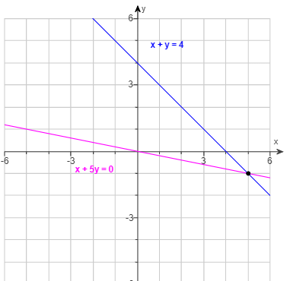 [6.1.25]

The **solution** to the system is where the lines **______________**: $_________________$

* **EXAMPLE:** A system of two linear equations has been solved graphically. Use the graph to find any solutions. [6.1-17]

|  |  |
| --- | --- |
|  | **A.** There is an infinite number of solutions. |
| **B. $(3,2)$** |
| **C. $(2,3)$** |
| **D.** There are no solutions. |

## Three Types of Linear Systems

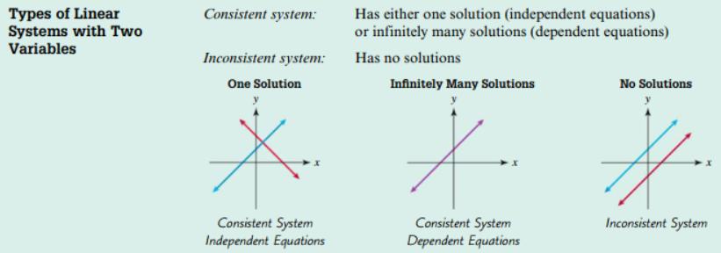

* **EXAMPLE:** Graph the system of equations and find any solutions. Check the answers. Identify the system as consistent or inconsistent. If the system is consistent, state whether the equations are dependent or independent. [6.1.35-Setup & Solve]

$$\left\{\begin{aligned}4x+y=8 \\ -4x-y=16\end{aligned}\right.$$

Solve each equation for *y* so that you can graph.

(show your work below)

$4x+y=8$ $-4x-y=16$

$y=$

$y=$

Use the graphing tool to graph the system.

|  |  |  |  |
| --- | --- | --- | --- |
| **Equation** | ***y*-intercept** | **Slope** | $$\frac{rise}{run}$$ |
| $${ y}_{1}=-4x+8$$ | $$(0, ___)$$ | **____** |  |
| $${ y}_{2}=-4x-16$$ | $$(0,_____)$$ | **____** |  |

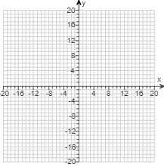

What is the solution of the system?

There is **__________________**.

Identify the system as consistent or inconsistent. If the system is consistent, state whether the equations are dependent or independent.

The system is: **_________________**.

Once you have your equations in slope-intercept form ($y=mx+b$), you can also verify you have the correct lines using your graphing calculator – assuming you made no errors.

|  |  |  |
| --- | --- | --- |
|  |  |  |
| 1. Press **Y=** button and enter your 2 equations you got into slope-intercept form. | 2. Press **WINDOW** button and adjust settings to match *x*-axis and *y*-axis in the answer graph. | 3. Press **GRAPH** button and this graph should match the one with the graphing tool.  The lines are parallel and do not intersect; therefore, the system is **INCONSISTENT** and has  **NO SOLUTION**. |

* **EXAMPLE:** Graph the system of equations and find any solutions. Check the answers. Identify the system as consistent or inconsistent. If the system is consistent, state whether the equations are dependent or independent. [6.1.39]

$$\left\{\begin{aligned}x-2y=-6 \\ -2x+y=6\end{aligned}\right.$$

Solve each equation for *y* so that you can graph.

(show your work below)

$1x-2y=-6$ $-2x+y=6$

$y=$

$$y=$$

Use the graphing tool to graph the system.

|  |  |  |  |
| --- | --- | --- | --- |
| **Equation** | ***y*-intercept** | **Slope** | $$\frac{rise}{run}$$ |
| $${ y}_{1}=\frac{1}{2}x+3$$ | $$(0, ____)$$ | $$_____$$ |  |
| $${ y}_{2}=2x+6$$ | $$(0,____)$$ | $$_____$$ |  |

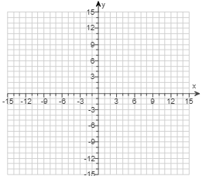

What is the solution of the system?

(Type an ordered pair.)

The solution is **_________**

Identify the system as consistent or inconsistent. If the system is consistent, state whether the equations are dependent or independent.

The system is: **_____________** and the equations are **________________**.

Once you have your equations in slope-intercept form ($y=mx+b$), you can also verify you have the correct lines using your graphing calculator – assuming you made no errors.

|  |  |  |
| --- | --- | --- |
|  |  |  |
| 1. Press **Y=** button and enter your 2 equations you got into slope-intercept form. | 2. Press **WINDOW** button and adjust settings to match *x*-axis and *y*-axis in the answer graph. | 3. Press **GRAPH** button and this graph should match the one with the graphing tool. |

(problem continued from previous page)

|  |  |  |  |
| --- | --- | --- | --- |
|  |  |  |  |
| 1. Press **Y=** button and enter your 2 equations you got into slope-intercept form. | 2. Press **WINDOW** button and adjust settings to match *x*-axis and *y*-axis in the answer graph. | 3. Press **GRAPH** button and this graph should match the one with the graphing tool. | 4. Press the buttons **2ND TRACE 5**  which is in the **CALCULATE** menu - **intersect** |
|  |  |  |  |
|  |  |  |  |
| 5. First Curve?  Press **ENTER** | 6. Second Curve?  Press **ENTER** | 7. Guess?  Press **ENTER** | 8. Intersection  (Use BOTH *x* and *y*) $x=-2$ **and $y=2$ $$(-2,2)$$**  The lines TOUCH at exactly ONE point, so the system is **CONSISTENT** and **INDEPENDENT**. |

* **EXAMPLE:** Solve the system of equations by graphing. Then classify the system.

$\left\{\begin{aligned}x+y=2 \\ 8x+8y=16\end{aligned}\right.$ [6.1.41]

Solve each equation for *y* so that you can graph.

(show your work below)

$x+y=2$ $8x+8y=16$

$y=$

$y=$

These equations are the **______** line! Since they TOUCH on top of each other, it’s **_____________** and **______________**.

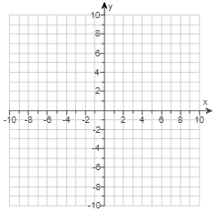

|  |  |  |
| --- | --- | --- |
| ***y*-intercept** | **Slope** | $$\frac{rise}{run}$$ |
| $$(0, ____)$$ | **____** |  |

There are **______________________** solutions.

Sources used:

1. Pearson MyLab Math College Algebra with Modeling and Visualization, 6th Edition, Rockswold
2. Wabbitemu calculator emulator version 1.9.5.21 by Revolution Software, BootFree ©2006-2014 Ben Moody, Rom8x ©2005-2014 Andree Chea. Website <https://archive.codeplex.com/?p=wabbit>